**LINUX COMMANDS**

1. **pwd:** Print working directory – prints the full filename of the current working directory

Syntax: pwd [options]

Options:

-P            The pathname printed will not contain symbolic links

-L            The pathname printed may contain symbolic links

1. **vi:** Visual text editor

Syntax: vi [options]

Example Options:

-| -s       Suppress all interactive user feedback.

-l             Set up for editing LISP programs.

-r             List the name of all files saved as the result of an editor or system crash.

1. **touch:** update last modified time and date of the file. Also to create a new empty file with current date and time

Syntax: touch [options] File

Example Options:

-a                                                            update only the access time.

-B, --backward=SECONDS             Modify the time by going back SECONDS seconds.

-c, --no-create                                   do not create any files.

1. **mkdir:** create one or more directories

Syntax: mkdir [options] directories

Example Options:

-m          Set the access mode for the new directories.

-p            Create intervening parent directories if they don't exist.

-v            Print help message for each directory created.

1. **rm:** remove/delete the file from the directory

Syntax: rm [options..] [file|directory]

Example Options:

-f                             Remove all files in a directory without prompting the user.

-i                             Interactive - prompts for confirmation before removing any files.

-r (or) -R               Recursively remove directories and subdirectories in the argument list.

1. **ls:** List the files and directories under current working directory

Syntax: ls [OPTIONS]… [FILE]

Example Options:

-l             Lists all the files, directories and their mode, Number of links, owner of the file, file size, Modified date and time and filename.

-t             Lists in order of last modification time.

-a            Lists all entries including hidden files.

-d            Lists directory files instead of contents.

1. **echo:** prints the given input string to standard output

Syntax: echo [options..] [string]

Example Options:

-n            do not output the trailing newline

-e            enable interpretation of the backslash-escaped characters listed below

-E            disable interpretation of those sequences in STRINGs

1. **cat:** concatenates files and print it on the standard output

Syntax: cat [options] [FILE]…

Example Options:

-A           Show all.

-b            Omits line numbers for blank space in the output.

-e            A $ character will be printed at the end of each line prior to a new line.

1. **who:** lists the names of users currently logged in, their terminal, the time they have been logged in and the name of the host from which they have logged in.

Syntax: who [options] [file]

am i        Print the username of the invoking user, The 'am' and 'i' must be space separated.

-b            Prints time of last system boot.

-d            print dead processes.

1. **cd:** Change directory

Syntax: cd [directory | ~ | ./ | ../ | - ]

Example Options:

-L            Use the physical directory structure.

-P            Forces symbolic links.

1. **date:** prints date and time

Syntax: date [options] [+format] [date]

Example Options:

-a                            Slowly adjust the time by sss.fff seconds (fff represents fractions of a second).

-sdate-string      Sets the time and date to the value specfied in the datestring.

-u                            Display (or set) the date in Greenwich Mean Time (GMT-universal time).

1. **cal:** display calender

Syntax: cal [options] [month] [year]

Example Options:

-1            Displays single month as output.

-3            Displays prev/current/next month output.

-s            Displays sunday as the first day of the week.

1. **mv:** move/rename file from one directory to another without retaining a copy

Syntax: mv [-f] [-i] <oldname> <newname>

Example Options:

-f             This will not prompt before overwriting (equivalent to --reply=yes). mv-f will move the file(s) without prompting even if it is writing over an existing target.

-i             Prompts before overwriting another file.

1. **cp:** copy file(s) from one location to another.

Syntax:

cp [OPTIONS]… <Source> <Destination>

cp [OPTIONS]… <source>… <Directory>

cp [OPTIONS]… --target-directory=DIRECTORY SOURCE…

Example Options:

-a                                            same as -dpR.

--backup[=CONTROL]     make a backup of each existing destination file

-b                                            like --backup but does not accept an argument.

-f                                             if an existing destination file cannot be opened, remove it and try again.

1. **which:** show the full path of the given executable command

Syntax: which [options][--] <program name> […]

Example Options:

--all, -a                  Print all matching executables in PATH, not just the first./td>

--read-alias, -i    Read aliases from stdin, reporting matching ones on stdout.

--skip-alias          Read shell function definitions from stdin, reporting matching ones on stdout.

**Screenshots:**

Vi – visual text editor

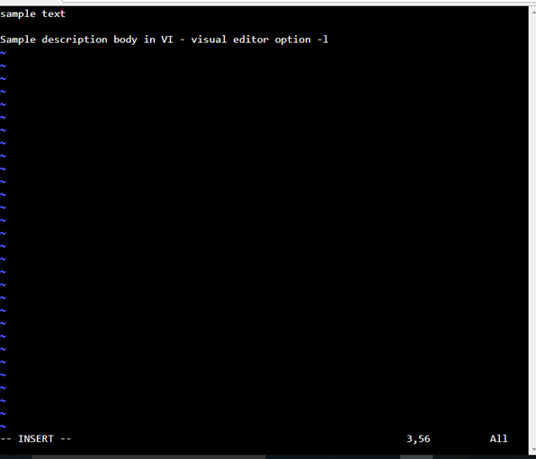

Mv, cp, rm: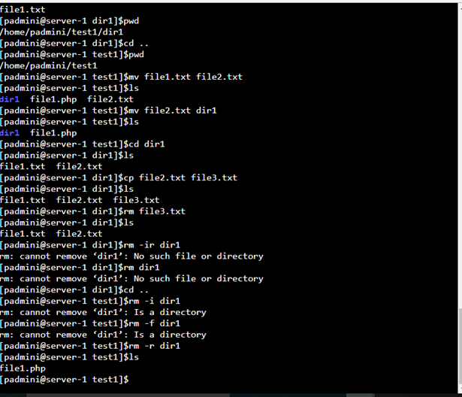

Pwd, mkdir, cd:

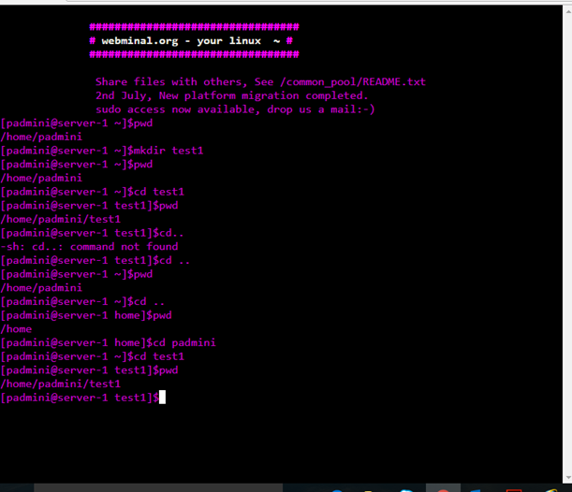

Date, cal, echo, who, which:

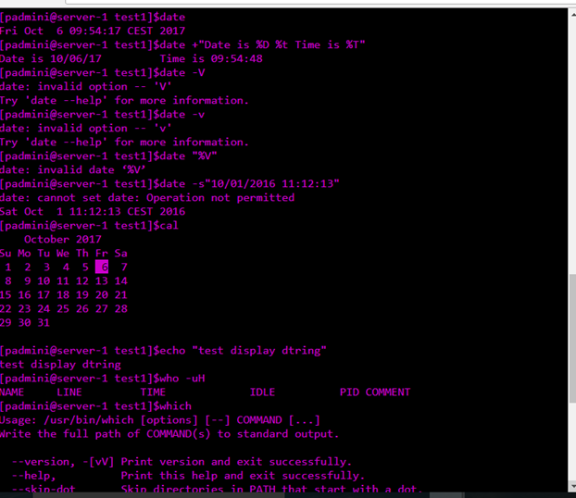

touch, ls, cat:

